
IEEE ISIE 2027  Special Session Proposal  36th IEEE International Symposium on Industrial Electronics  Paris, France · June 30 – July 03, 2027 | 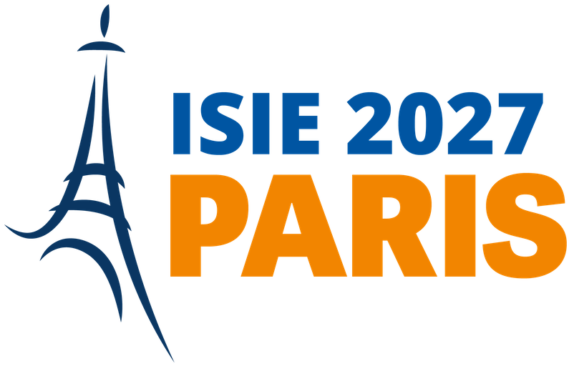

1 Special Session identification

Session title
Keywords (3–5)
Expected submissions | ☐ 5–8 papers (one session slot) ☐ 9–16 papers (two session slots)
The Technical Track must be selected from the 24 Regular Tracks listed on the Technical Tracks page of the conference website.

2 Organizers
One Principal Organizer is required. Up to two Co-Organizers may be listed. Proposals involving organizers from at least two different institutions and countries are strongly encouraged.
Principal Organizer — required
First name |  | Last name
Affiliation
Country |  | Email address
IEEE / IES status | ☐ IEEE Member ☐ IEEE IES Member ☐ Non-member

Co-Organizer 1 — optional
First name |  | Last name
Affiliation
Country |  | Email address
IEEE / IES status | ☐ IEEE Member ☐ IEEE IES Member ☐ Non-member

Co-Organizer 2 — optional
First name |  | Last name
Affiliation
Country |  | Email address
IEEE / IES status | ☐ IEEE Member ☐ IEEE IES Member ☐ Non-member

3 Organizer commitments
Declaration
- Each person listed above is involved in no more than two IEEE ISIE 2027 Special Session proposals.
- All persons listed above have agreed to act as organizers of this Special Session.
- The organizers will actively promote the Special Session and support the submission of high-quality papers.
- The organizers understand that all Special Session papers undergo the same peer-review process and quality standards as regular papers.
- The organizers understand that a Special Session receiving an insufficient number of accepted papers may be merged with a regular session.
- At least one organizer will register for and attend IEEE ISIE 2027 to chair the session.
- The organizers will not review papers for which they have a conflict of interest, including their own submissions.

4 Call for Papers
The text provided below will be published as-is on the conference website. Please write in clear, self-contained English.
4.1 Session description
Approximately 200 words presenting the theme, scope, motivation and scientific relevance of the proposed Special Session, and its relationship with the conference theme.

4.2 Topics of interest
List between 5 and 10 topics to be covered by the Special Session. Items 6 to 10 are optional.
N° | Topic
1
2
3
4
5
6
7
8
9
10

5 Potential authors
List between 6 and 10 researchers who are likely to submit a paper to this Special Session. Items 7 to 10 are optional. Listing a person does not commit them to submitting.
N° | Name and affiliation | Email address
1
2
3
4
5
6
7
8
9
10

6 Proposed reviewers
List between 10 and 20 reviewers with the expertise required to review submissions to this Special Session. Items 11 to 20 are optional. Reviewers must not be co-authors of papers they review.
N° | Name and affiliation | Email address
1
2
3
4
5
6
7
8
9
10
11
12
13
14
15
16
17
18
19
20

7 Submission procedure

1. Complete every section of this template.
2. Save the file as ISIE2027_SS_LastName_ShortTitle.docx.
3. Send the completed Word document to special-sessions@isie2027-paris.org with the subject line:
ISIE 2027 – Special Session Proposal – [Session Title]
4. You will receive an acknowledgement of receipt within few working days. If you do not, please resend your proposal.
Reference pages
Call for Special Sessions: isie2027.ieee-ies.org/call-for-papers/call-for-special-sessions/
Important Dates: isie2027.ieee-ies.org/important-dates/
Technical Tracks: isie2027.ieee-ies.org/call-for-papers/technical-tracks/

8 Deadlines
The Important Dates page of the conference website is the authoritative reference. Dates may evolve.
Milestone | Date
Special Session proposal submission | November 1, 2026
Special Session proposal acceptance notification | To be confirmed — see Important Dates page
Regular & Special Session paper submission | December 15, 2026
Early acceptance notification (authors requiring a visa) | March 1, 2027
Notification of paper acceptance | March 15, 2027
Final manuscript submission & author registration | April 15, 2027

9 Selection criteria
Proposals are evaluated by the Special Sessions Chairs against the following criteria.
▪ Scientific relevance and timeliness of the topic within the scope of IEEE ISIE 2027.
▪ Alignment with the conference theme and with one of the 24 Regular Technical Tracks.
▪ Expertise and international standing of the organizing team.
▪ Institutional, geographic and gender diversity of organizers, potential authors and reviewers.
▪ Realistic prospects of attracting a sufficient number of high-quality submissions.
▪ Complementarity with the regular technical programme and with other Special Session proposals.
Personal data
The names, affiliations and email addresses provided in this form are collected by the IEEE ISIE 2027 Organizing Committee for the sole purpose of evaluating this proposal and, if accepted, organizing the corresponding Special Session and its review process. Organizers confirm that they are entitled to share the contact details listed in Sections 5 and 6. Data are processed in accordance with the IEEE Privacy Policy and applicable European data protection law, and are deleted at the latest twelve months after the conference.

